1 x DM32 WiFi Digital Gauge Package
- DM32 WiFi Dual Channel Color Touchscreen Manometer
- USB Cable, 6' (1.8 m)
- Cat5 Cable, 7' (2 m) Blue
- DM32 USB Charging Module (120V/60Hz, 240V/50Hz, or 110V/50Hz)
- Gauge Case
- DM32 Magnetic Clip
- ISO17025 calibration of DM32
- Gauge Calibration Verification Report
1 x 6000 Series Fan Set
- 6000 Series Calibrated Fan (120V/60Hz, 240V/50Hz, or 110V/50Hz)
- Range Ring A for 5000/6000 Series Fan
- B8 Plate for 5000/6000 Series Fan
- 1 x High Power Drive for 6000 Series Fan (120V/60Hz, 240V/50Hz, or 110V/50Hz)
- Range 74,47, 29
- 8 x 4" Blank Plugs
- Power Cord
- 2 x Fan Cover
- System Calibration Verification Report
1 x Hard Panel Set for 1000/5000/6000 Series Fan
1 x Blower Door Tubing Kit
4 x Roll of Grill Masks
1 x Umbilical for 1000/5000/6000 Series Fan, 7 ft (2 m)
1 x Large Frame Package
1 x Fan Case
1 x Accessory Case
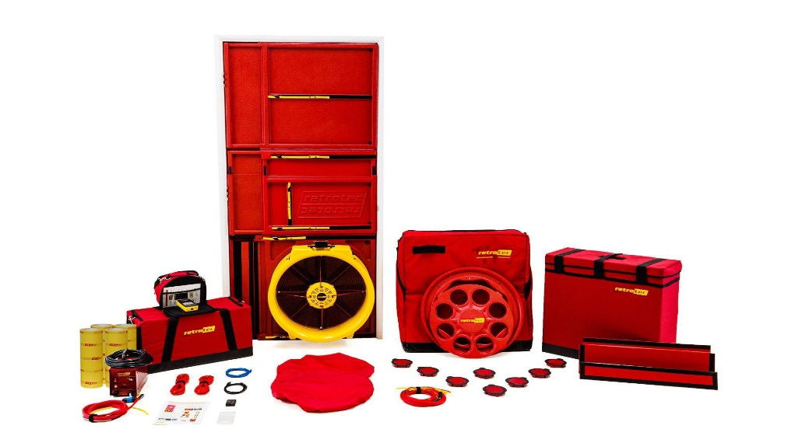

Specifications below are for each individual fan.
Fan Model #: | 6000
 | Flow Into: | CFM | litres/sec | m3/h
Maximum Flow*, per fan | Free Air | 8,100 | 3,823 | 13,762
 | 50 Pa | 7,700 | 3,634 | 13,082
 | 75 Pa | 7,400 | 3,492 | 12,573
Minimum Flow:  on Range 29 | 50 Pa | 9 | 4 | 15
Dimensions: | 26" × 25.5" × 9.5" (66 x 65 x 24 cm)
Weight: | 36.3 lb (16.5 kg) or 38 lb (17.2 kg) with Ring A & Plated B8 installed
Flow Accuracy: | +/-5%
Power: | 120V@60hz/22.0A or 240V@50hz/10.9A or 110V@50Hz/22.0A
Recommended Fan Calibration Interval: | 5 years

