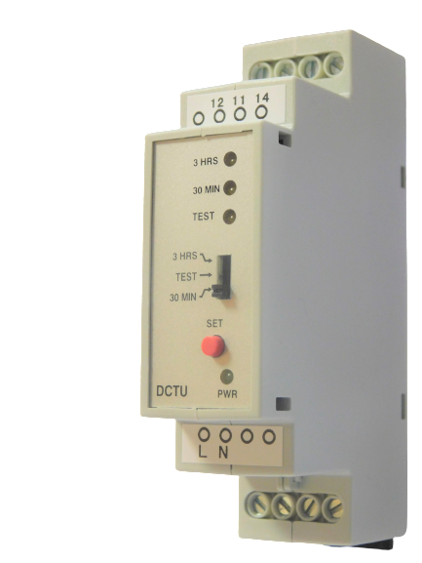
CTU (CENTRAL TEST UNIT)
PANEL MOUNTED TIMER (733 SERIES)

Status LED’s
tatus LED’s
CTU (CENTRAL TEST UNIT)
TESTING OF EMERGENCY LIGHTING CIRCUITS

Output Switch

Manual Test

Applications

Central Test Unit
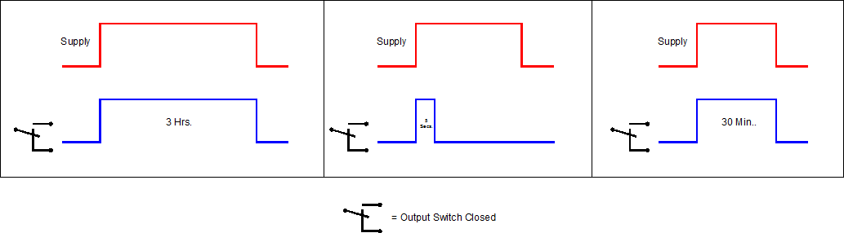

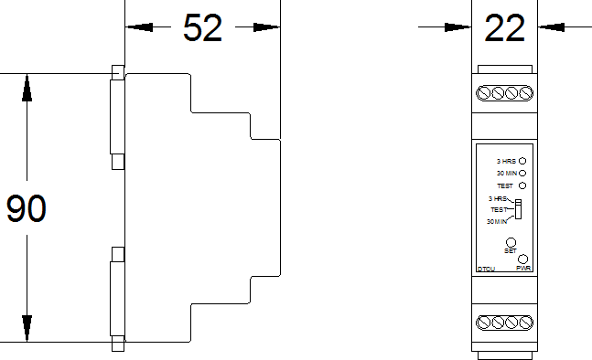
Technical Specification

- Testing of Emergency Lighting Circuits

Every effort has been taken to ensure the accuracy of this specification. However in order to maintain our technological lead we are continuously improving our products which could, without notice result in amendments or omissions to this specification. We cannot accept responsibility for damage, injury, loss or expenses resulting therein.

Product No. 733-10-000
Timing Scale | T1 Time |  | 30 Min. |  | T1 Time |  | 3 Hrs.
Supply Voltage |  | 240 VAC 50/60Hz Other voltages available on request
Current Consumption |  | 4mA Max. |  | Timing Temp. Coefficient |  | + or – 0.005% °C
Operating Temp. |  | -10 to +60°C |  | Scale Accuracy |  | + or -10%
 |  |  |  | Reset/ Test |  | Manual Touch Switch
Switch Capacity |  | 1 Amp. |  | Printed Circuit Board |  | UL 94V0
Inrush Current |  | 10 Amps for 10mSec |  | Repeat Accuracy |  | + or – 1%
Switching Holding Voltage |  | 400V |  | Indicators |  | LED’s to indicate phases
Duty Cycles |  | 100% |  | Design Standard |  | VDE 0110C
Input |  | Screw Clamp Terminals |  | Output |  | Screw Clamp Terminals

FOR FURTHER INFORMATION CONTACT US BY EMAIL SALES@RFE.IE OR CALL 01 4659010 RFE, UNIT 19 OAK ROAD BUSINESS PARK, WESTERN INDUSTRIAL ESTATE, DUBLIN 12

